Uygulama ekranı

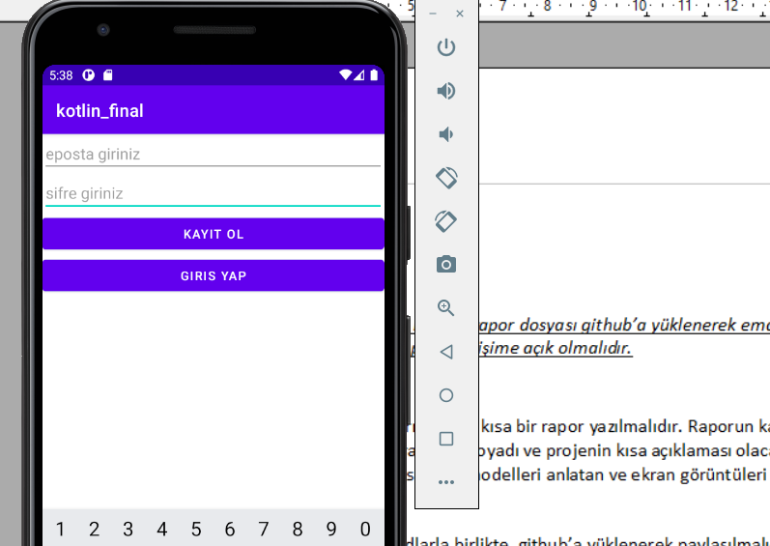

SqliteHelper sınıfı

class IboHelper(var context:Context, var name:String, var version:Int):SQLiteOpenHelper(context,name,null,version) {
val table_name="uyeler"
val id_column_create="id integer primary key autoincrement"
val eposta_column_create="eposta varchar(256)"
val sifre_column_create="sifre varchar(256)"
val create_table_sql="create table $table_name( $id_column_create,$eposta_column_create,$sifre_column_create);"
val eposta_column_name="eposta"
val sifre_column_name="sifre"
override fun onCreate(db: SQLiteDatabase?) {
db?.execSQL(create_table_sql)
}
override fun onUpgrade(db: SQLiteDatabase?, oldVersion: Int, newVersion: Int) {
TODO("Not yet implemented")
}
fun insertUye(eposta:String,sifre:String){
val contentValues = ContentValues()
val database=writableDatabase
contentValues.put(eposta_column_name, eposta)
contentValues.put(sifre_column_name, sifre)
val result = database.insert(table_name, null, contentValues)
if (result == (0).toLong()) {
Toast.makeText(context, "ekleme basarisiz", Toast.LENGTH_SHORT).show()
}
else {
Toast.makeText(context, "ekleme basarili", Toast.LENGTH_SHORT).show()
}
}
fun uyeExists(eposta:String,sifre:String):Boolean{
val db = this.writableDatabase
val selectQuery = "SELECT * FROM $table_name WHERE $eposta_column_name = '$eposta' and $sifre_column_name = '$sifre'"
db.rawQuery(selectQuery, null).use { // .use requires API 16
if (it.moveToFirst()) {
val eposta_result = it.getInt(it.getColumnIndex(eposta_column_name))
val sifre_result = it.getString(it.getColumnIndex(sifre_column_name))
return true
}
}
return false
}
}

MainActivity sınıfı

class MainActivity : AppCompatActivity() {
var eposta_input:EditText?=null
var sifre_input:EditText?=null
var helper:IboHelper?=null
override fun onCreate(savedInstanceState: Bundle?) {
super.onCreate(savedInstanceState)
setContentView(R.layout.activity_main)
eposta_input=findViewById(R.id.Eposta)
sifre_input=findViewById(R.id.Sifre)
helper= IboHelper(this,"ibo_db",1)
}
fun sign_up(view:View){
val name= eposta_input?.text.toString()
val pass= sifre_input?.text.toString()
if(!name.isNullOrEmpty()&&!pass.isNullOrEmpty()){
val exists= helper?.uyeExists(name,pass)
if(!exists!!){
helper?.insertUye(name,pass)
}
else{
Toast.makeText(this, "uye zaten var", Toast.LENGTH_SHORT).show()
}
}
else{
Toast.makeText(this, "gecersiz giris", Toast.LENGTH_SHORT).show()
}
clearInputs()
}
fun sign_in(view:View){
val name= eposta_input?.text.toString()
val pass= sifre_input?.text.toString()
if(!name.isNullOrEmpty()&&!pass.isNullOrEmpty()){
val exists= helper?.uyeExists(name,pass)
if(exists!!){
Toast.makeText(this, "giris basarili", Toast.LENGTH_SHORT).show()
}
else{
Toast.makeText(this, "giris basarisiz", Toast.LENGTH_SHORT).show()
}
}
else{
Toast.makeText(this, "gecersiz giris", Toast.LENGTH_SHORT).show()
}
clearInputs()
}
fun clearInputs(){
eposta_input?.setText("")
sifre_input?.setText("")
}
}

activity_main.xml

<?xml version="1.0" encoding="utf-8"?>
<androidx.constraintlayout.widget.ConstraintLayout xmlns:android="http://schemas.android.com/apk/res/android"
xmlns:app="http://schemas.android.com/apk/res-auto"
xmlns:tools="http://schemas.android.com/tools"
android:layout_width="match_parent"
android:layout_height="match_parent"
tools:context=".MainActivity">
<LinearLayout
android:id="@+id/linearLayout"
android:layout_width="0dp"
android:layout_height="0dp"
android:orientation="vertical"
app:layout_constraintBottom_toBottomOf="parent"
app:layout_constraintEnd_toEndOf="parent"
app:layout_constraintStart_toStartOf="parent"
app:layout_constraintTop_toTopOf="parent">
<EditText
android:id="@+id/Eposta"
android:layout_width="match_parent"
android:layout_height="wrap_content"
android:ems="10"
android:hint="eposta giriniz"
android:inputType="textPersonName" />
<EditText
android:id="@+id/Sifre"
android:layout_width="match_parent"
android:layout_height="wrap_content"
android:ems="10"
android:hint="sifre giriniz"
android:inputType="textPassword" />
<Button
android:id="@+id/kayit_btn"
android:layout_width="match_parent"
android:layout_height="wrap_content"
android:onClick="sign_up"
android:text="kayit ol" />
<Button
android:id="@+id/giris_btn"
android:layout_width="match_parent"
android:layout_height="wrap_content"
android:onClick="sign_in"
android:text="giris yap" />
</LinearLayout>
</androidx.constraintlayout.widget.ConstraintLayout>

